PROJECT REPORT

Project Name: GAS LEAKAGE MONITORING AND

ALERTING SYSTEM

Team ID: PNT2022TMID35113

Team:

PRAVINA. N

PRIYA DHARSHINI. T

PRIYA. S.V

SUGANYA. M

1.INTRODUCTION

1.1Project Overview

1.2 Purpose

2. LITERATURE SURVEY

2.1 Existing Problem

2.2 References

2.3 Problem statement Definition

3.IDEATION & PROPOSED SOLUTION

3.1Empathy Map Canvas

3.2 Ideation & Brainstorming

3.3 Proposed Solution

3.4 Problem Solution Fit

4. REQUIREMENT ANALYSIS

4.1 Functional Requirement

4.2 Non-Functional Requirement

5.PROJECT DESIGN

5.1 Data Flow Diagrams

5.2 Solution & Technical Architecture

5.3 User Stories

6.PROJECT PLANNING & SCHEDULING

6.1 Sprint Planning & Scheduling

6.2 Sprint Delivery Schedule

7. CODING & SOLUTIONING

7.1 Feature 1

7.2 Feature 2

8.TESTING

9.RESULTS

10.ADVANTAGES & DISADVANTAGES

11. CONCLUSION

12. FUTURE SCOPE

13. APPENDIX

Source Code

GitHub & Project Demo Link

1.INTRODUCTION

1.1 Project Overview

Leakage of any kind of gas has been a concern in recent years, whether it is in a residential setting, a business, a cafe, or a canteen. In this paper development of an IoT based gas wastage monitoring, leakage detecting and alerting system is proposed. This paper elaborates design such an intelligent system that will help save gas and smartly prevent accidents. The system needs to be integrated with the cooker. The technology includes ultrasonic sensors that determine if the cooker is being utilized for cooking purposes or not. If it is discovered that the cooker is not in use, the system uses an automatic switching off mechanism to cut off the gas supply. The moment gas leakage will probably be recognized, users will be informed via SMS through GSM, and so that user can solve the issue as soon as possible. The system will monitor flame and fire through flame sensor. When a fire is detected, the buzzer begins to sound. Aside from that, the system also has a cloud storage capability. The usage of gas for each user each day may be tracked with the aid of this cloud storage solution. At the end of the day, this procedure will assist in detecting peruser natural gas usage. The system has been tested and it is able to monitor gas wastage, leakage and send a SMS to the user. The resulting performance indicated its effectiveness toward saving a significant portion of the wasted gas in domestic.

1.2 Purpose

The design of a sensor-based automatic gas leakage detector with an alert and control system has been proposed. This is an affordable, less power using, lightweight, portable, safe, user friendly, efficient, multi featured and simple system device for detecting gas. Gas leakage detection will not only provide us with significance in the health department but it will also lead to raise our economy, because when gas leaks it not only contaminates the atmosphere, but also wastage of gases will hurt our economy. The need for ensuring safety in workplaces is expected to be the key driving force for the market over the coming years.

2.LITERATURE SURVEY

2.1 Existing Problem

Gas leakage is nothing but the leak of any gaseous molecule from a stove, or a pipeline, or cylinder etc. This can occur either purposefully or even unintendedly. As we are aware that these kinds of leaks are dangerous to our health, and when it becomes explosive it could cause great danger to the people, home, workplace, industry and the environment.

Few of the major incidents that took place due to gas leakage include the Bhopal Disaster and the Vizag Gas leak. The Bhopal disaster is known to be the worst industrial accident ever. Approximately 45 tons of Methyl Isocyanate was leaked from this insecticide plant. Methyl Isocyanate is an organic compound and a chemical that could come from the carbamate pesticides. This colourless, poisonous and flammable liquid is something that human beings have to be away from.

Vizag Gas leak was a resultant of the escape of styrene that were unattended for a long period. This colourless oily liquid can spread in fumes. So, a detector must be made in such a way that could detect any kind of gas, fume, leak, smoke etc. However harmful and dangerous it can be, the detector could be attached with certain parameters that could help to prevent the issue

2.2 References

[1] Mahalingam, A., R. T. Naayagi, and N. E. Mastorakis. "Design and implementation of an economic gas leakage detector." Recent Researches in Applications of Electrical and Computer Engineering, pp. 20-24, 2012.

[2] Attia, Hussain A., and Halah Y. Ali. "Electronic Design of Liquefied Petroleum Gas Leakage Monitoring, Alarm, and Protection System Based on Discrete Components." International Journal of Applied Engineering Research, vol. 11, no. 19, pp. 9721-9726, 2016.

[3] Apeh, S. T., K. B. Erameh, and U. Iruansi. "Design and Development of Kitchen Gas Leakage Detection and Automatic Gas Shut off System." Journal of Emerging Trends in Engineering and Applied Sciences, vol. 5, no. 3, pp. 222-228, 2014.

[4] T.Soundarya, J.V. Anchitaalagammai, G. Deepa Priya, S.S. Karthick kumar, “C-Leakage: Cylinder LPG Gas Leakage Detection for Home Safety,” IOSR Journal of Electronics and Communication Engineering, vol. 9, no. 1, Ver. VI, pp. 53-58, Feb. 2014.

[5] Ashish Shrivastava, Ratnesh Prabhakar, Rajeev Kumar, Rahul Verma, "GSM based gas leakage detection system." International Journal of Emerging Trends in Electrical and Electronics, vol. 3, no. 2, pp. 42-45, 2013

2.3 Problem Statement Definition

The system can be taken as a small attempt in connecting the existing primary gas detection methods to a mobile platform integrated with IoT platforms. The gases are sensed in an area of 1m radius of the rover and the sensor output dataare continuously transferred to the local server. The accuracy of sensors are not upto the mark thus stray gases are also detected which creates an amount of error in the outputs of the sensors, especially in case of methane. Further the avaiability and storage of toxic gases like hydrogen sulphide also creates problems for testing the assembled hardware. As the system operates outside the pipeline, the complication of system maintenance and material selection of the system in case of corrosive gases is reduced. Thus the system at this stage can only be used as a primary indicator of leakage inside a plant.

3.IDEATION & PROPOSED SOLUTION

3.1 Empathy Map Canvas

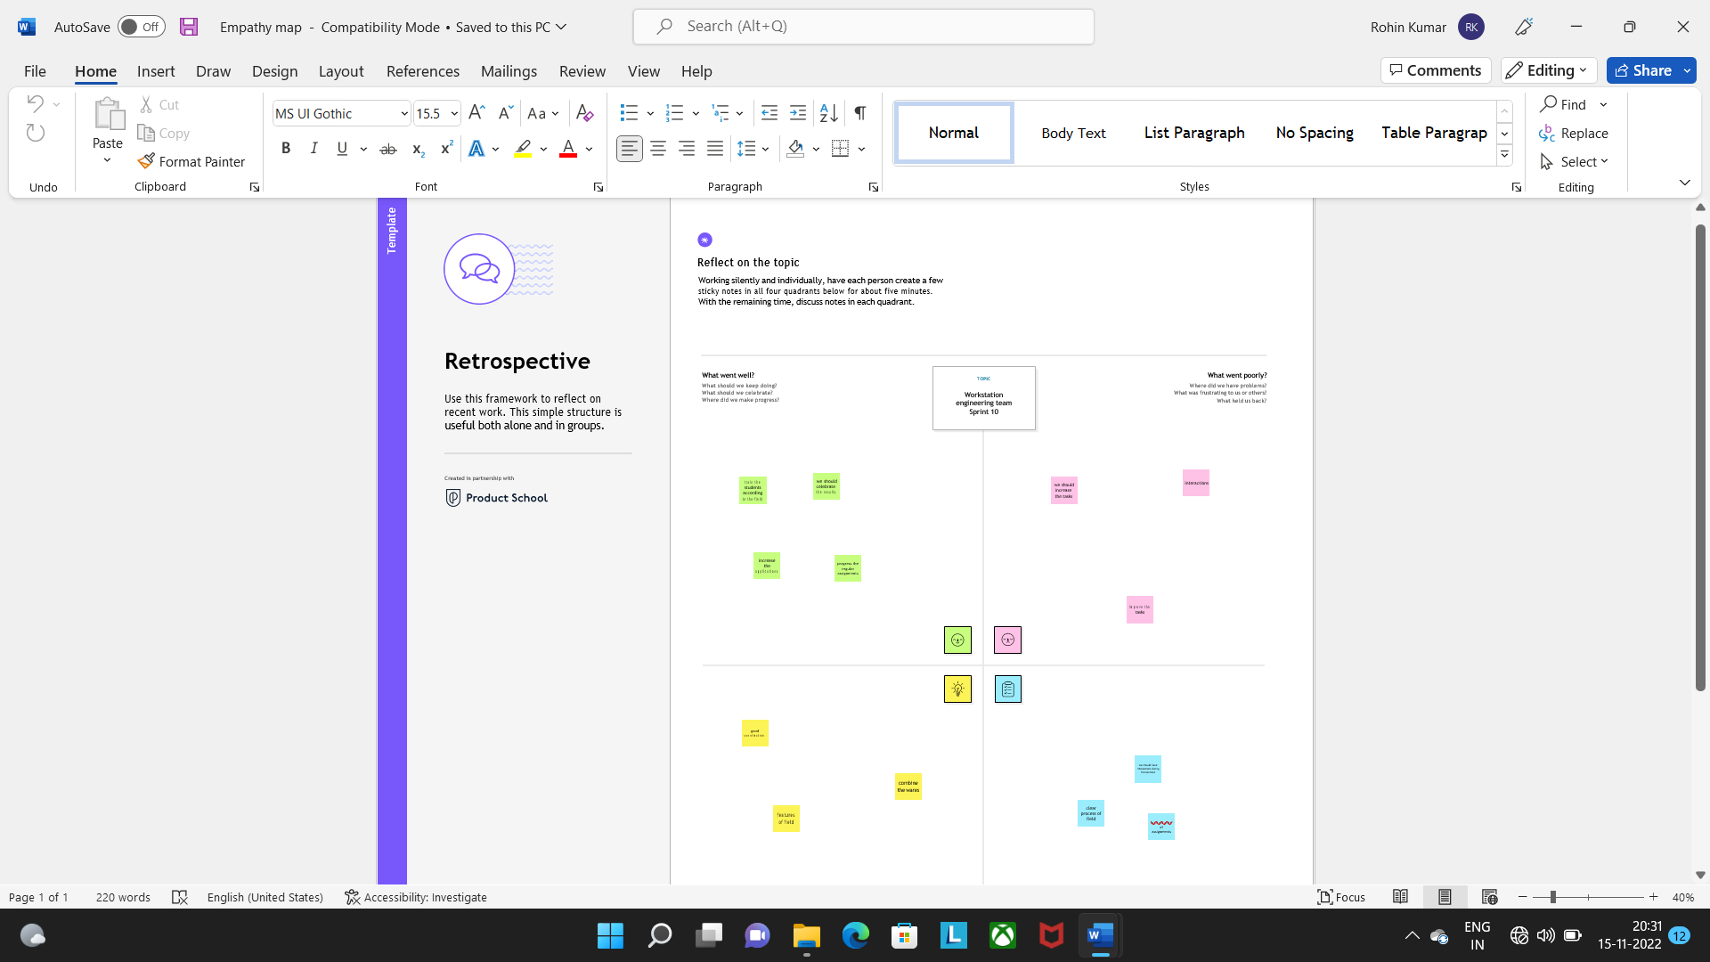

3.2 Ideation & Brainstorming

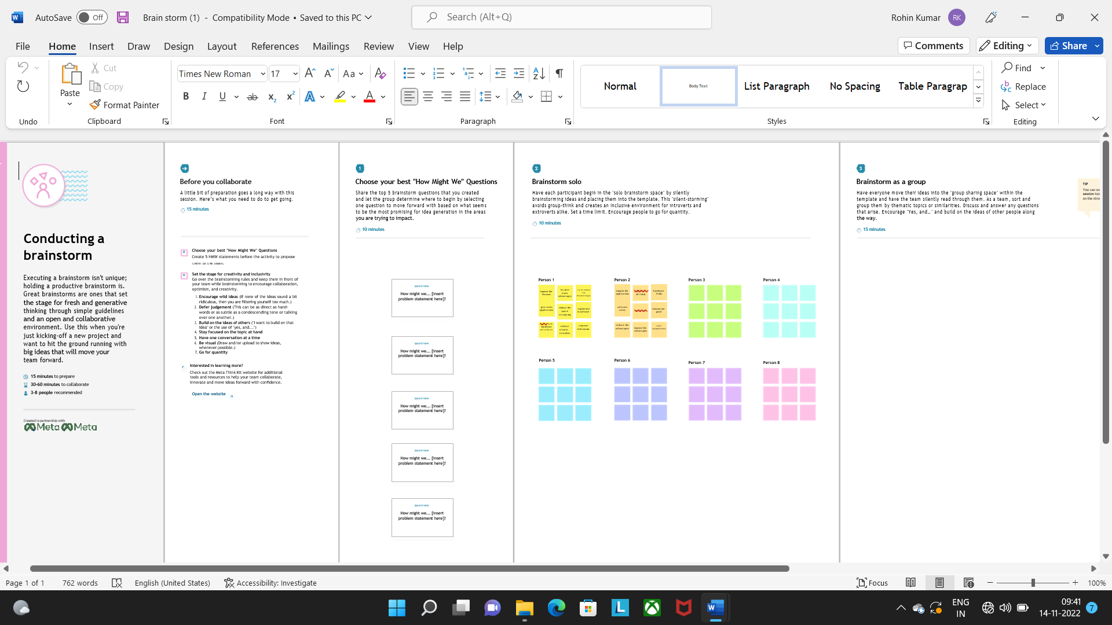

3.3 Proposed Solution

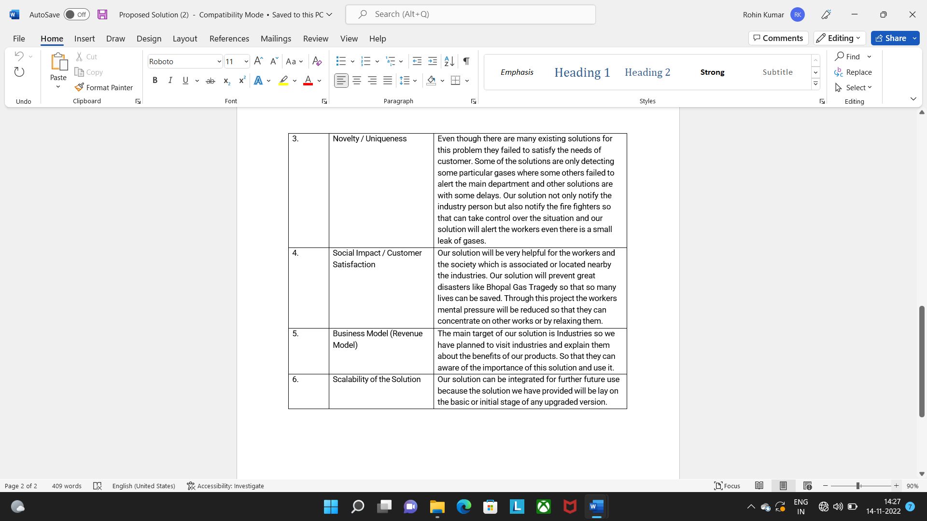

3.4 Problem Solution Fit

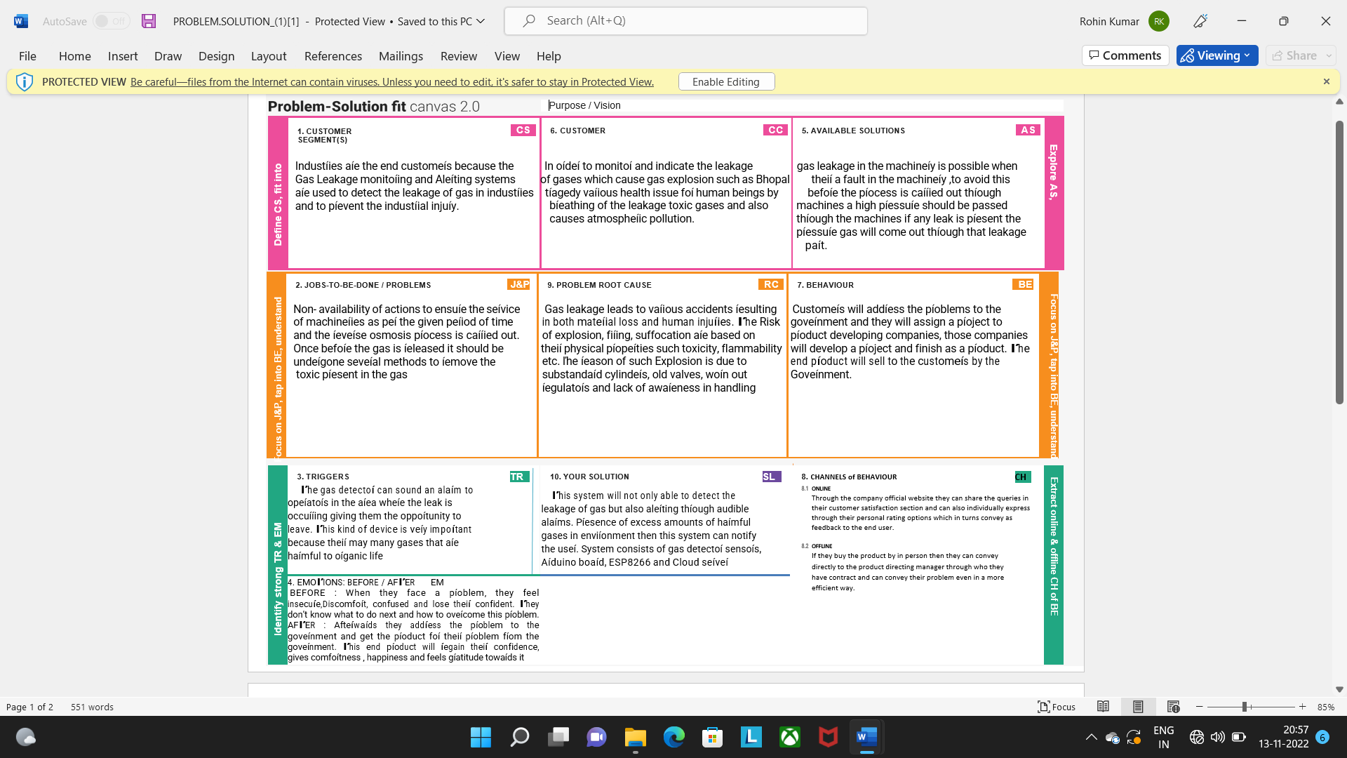

4.REQUIREMENT ANALYSIS

4.1 Functional Requirement

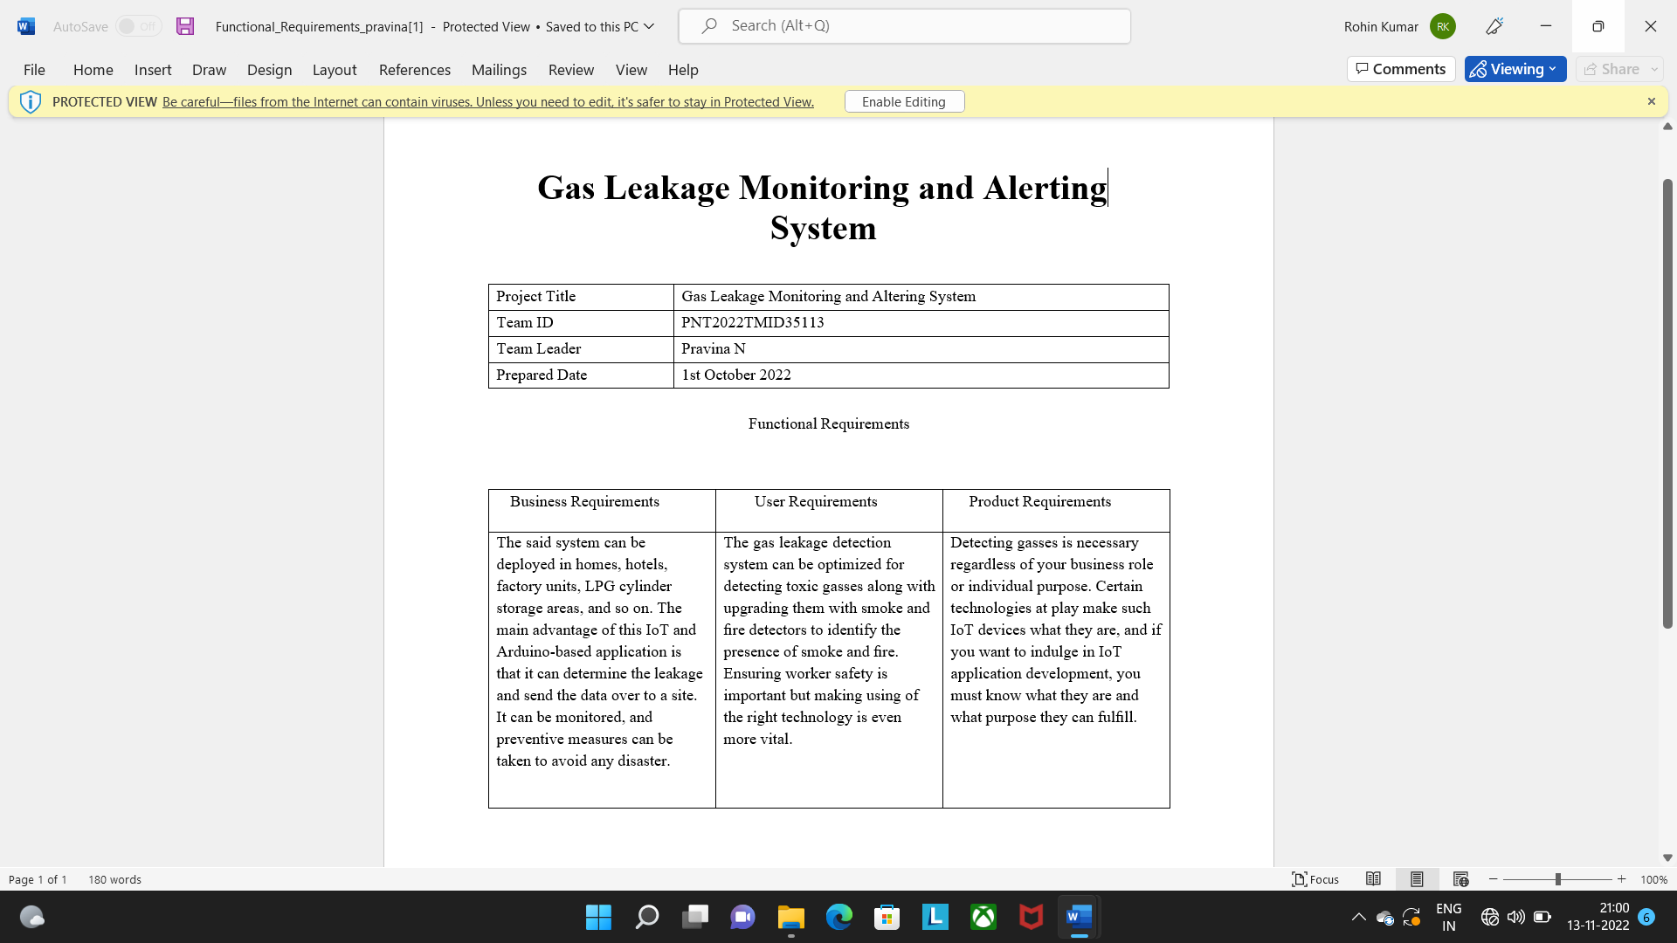

4.2 Non-Functional Requirements

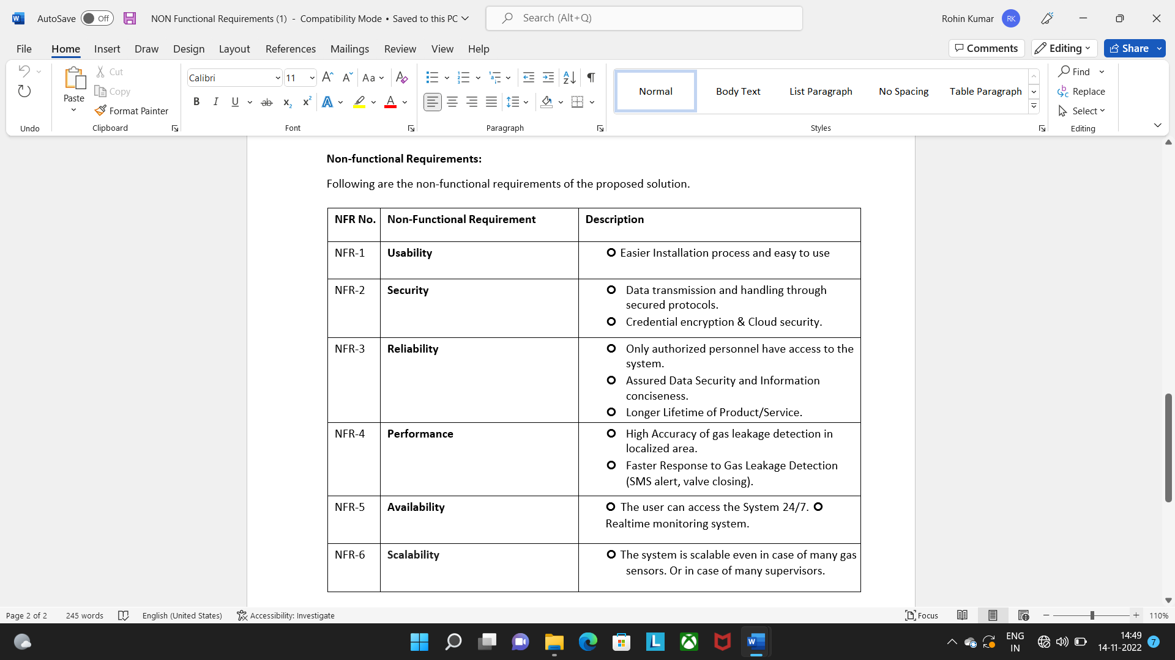

5.PROJECT DESIGN

5.1 Data Flow Diagrams

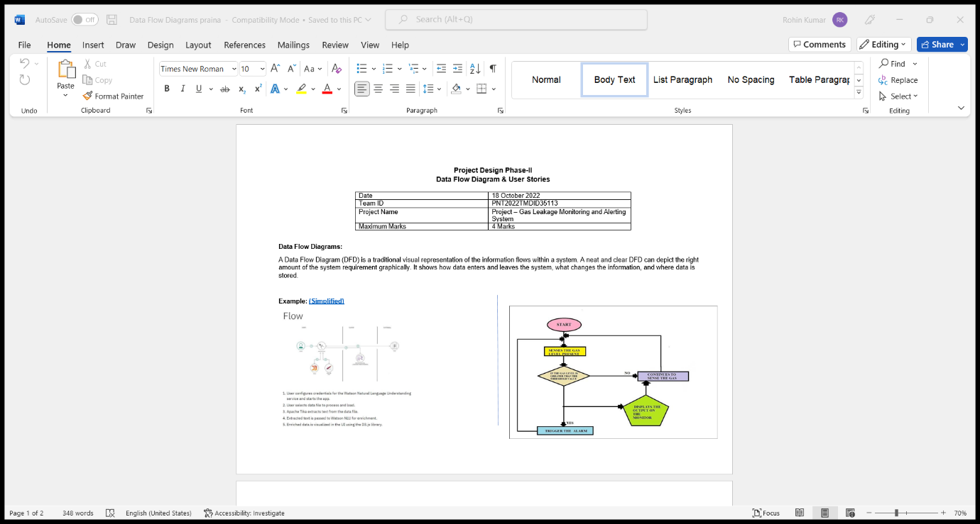

5.2 Solution & Technical Architecture

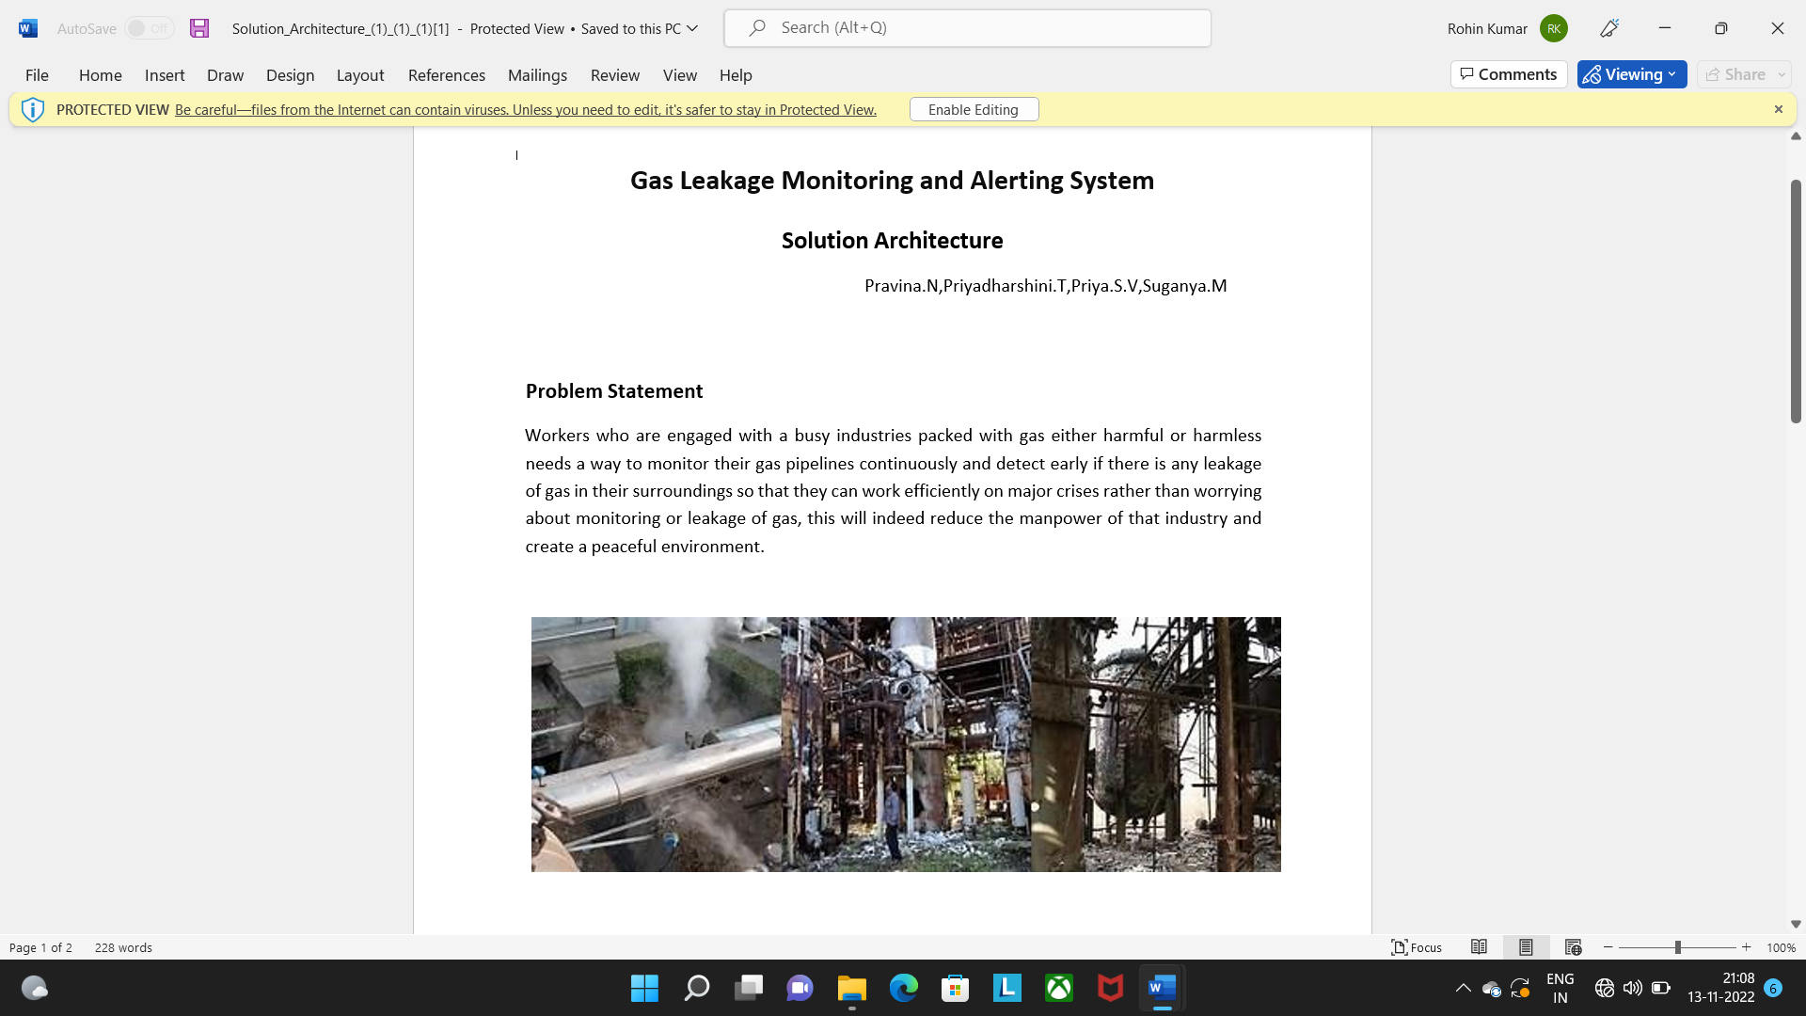

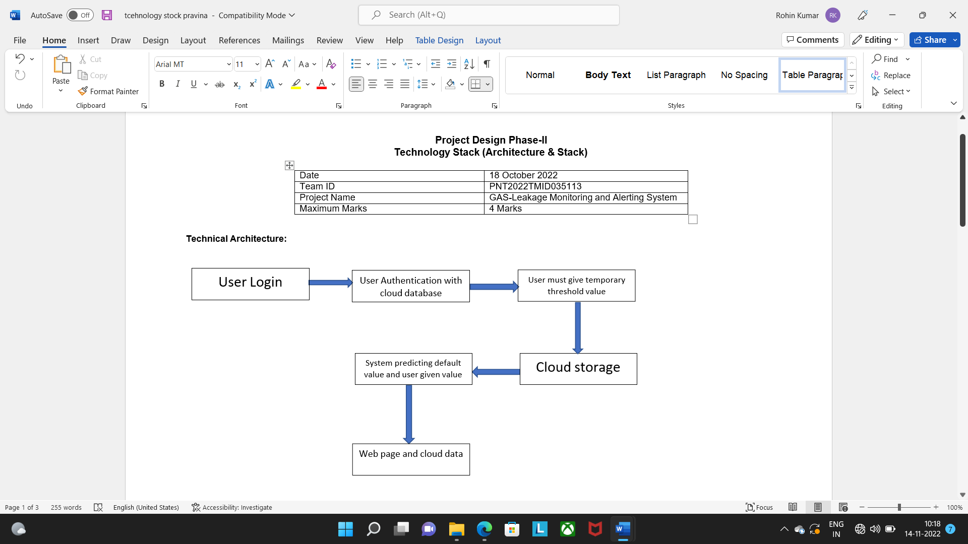

5.3 User Stories

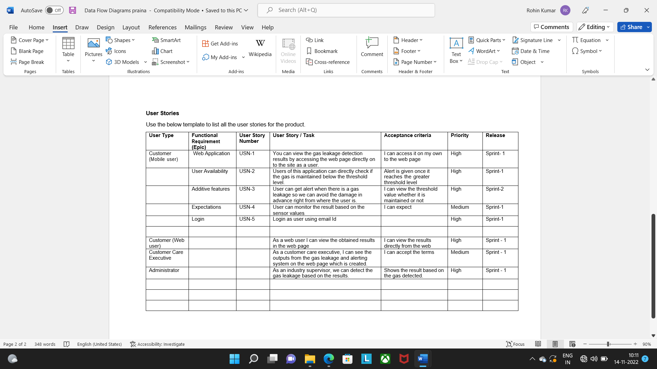

6.PROJECT PLANNING & SCHEDULING

6.1 Sprint Planning & Estimation

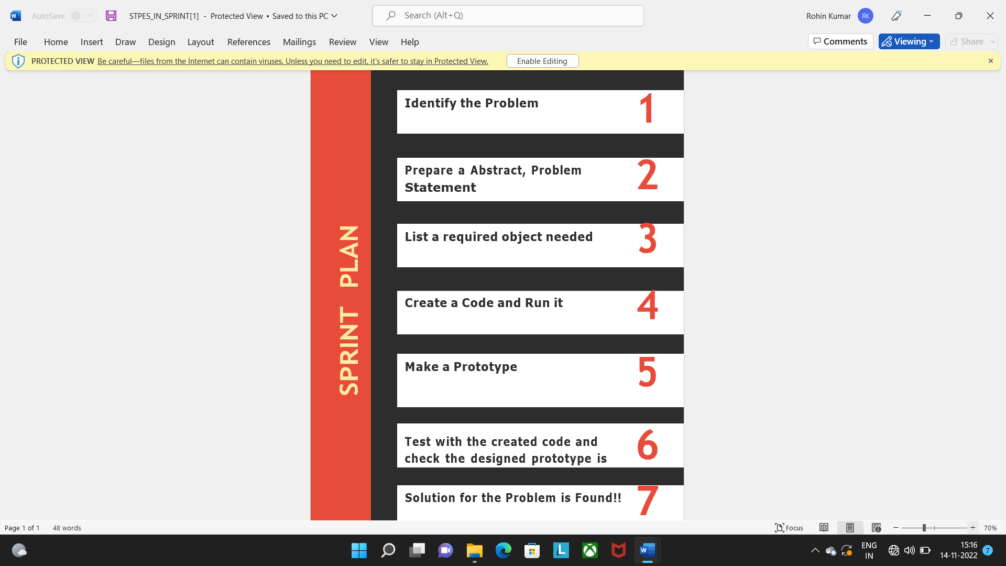

6.2 Sprint Delivery Schedule

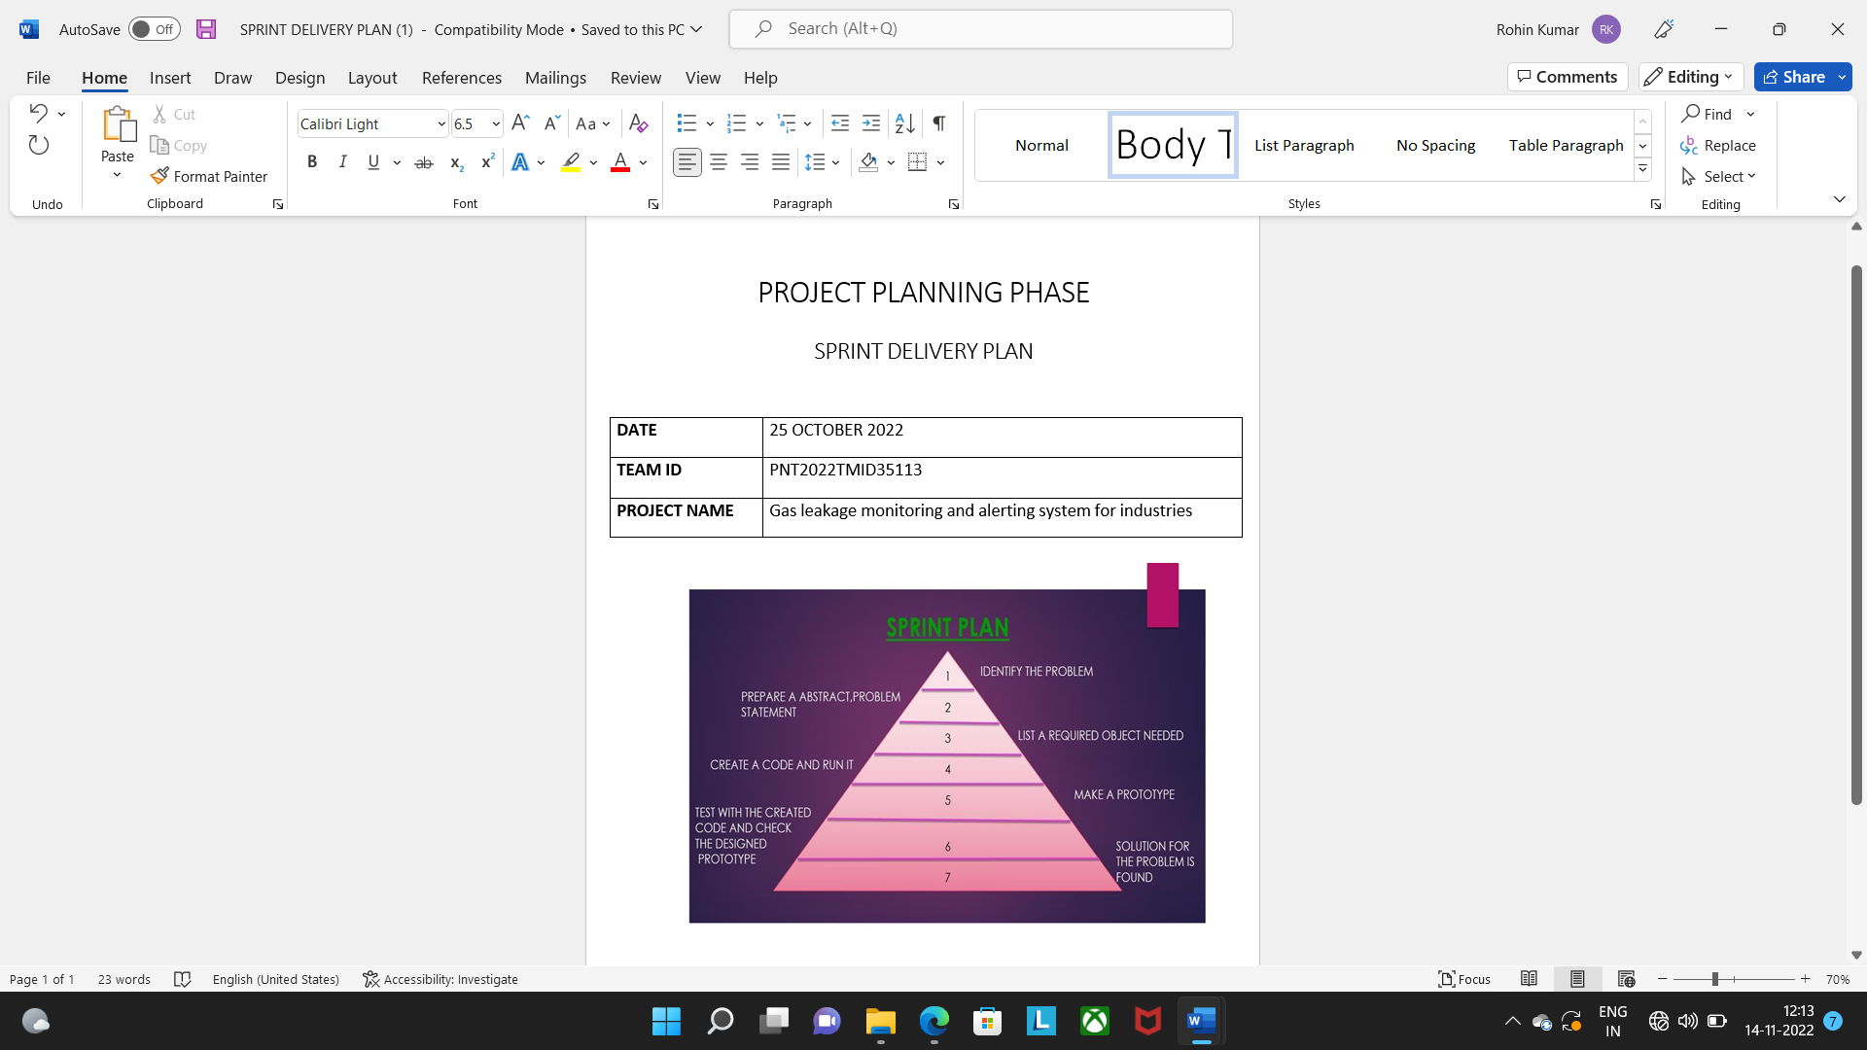

7.CODING & SOLUTIONING

7.1 Features 1

#include <LiquidCrystal.h> LiquidCrystal lcd(5,6,8,9,10,11);

int redled = 2; int greenled = 3; int buzzer = 4; int sensor = A0;

int sensorThresh = 400;

void setup()

{

pinMode(redled, OUTPUT); pinMode(greenled,OUTPUT); pinMode(buzzer,OUTPUT); pinMode(sensor,INPUT); Serial.begin(9600); lcd.begin(16,2);

}

void loop() { int analogValue = analogRead(sensor); Serial.print(analogValue); if(analogValue>sensorThresh)

{

digitalWrite(redled,HIGH); digitalWrite(greenled,LOW);

tone(buzzer,1000,10000

); lcd.clear(); lcd.setCursor(0,1); lcd.print("ALERT"); delay(1000); lcd.clear();

lcd.setCursor(0,1); lcd.print("EVACUATE");

delay(1000);

}

else

{

digitalWrite(greenled,HIGH); digitalWrite(redled,LOW); noTone(buzzer);

lcd.clear(); lcd.setCursor(0,0); lcd.print("SAFE"); delay(1000); lcd.clear(); lcd.setCursor(0,1); lcd.print("ALL CLEAR");

delay(1000);

}

}

7.2 Features 2

#include &lt;LiquidCrystal.h&gt;

LiquidCrystal lcd(5,6,8,9,10,11);

int redled = 2;

int greenled =

3; int buzzer =

4; int sensor =

A0;

int sensorThresh = 400;

void setup()

{

pinMode(redled, OUTPUT);

pinMode(greenled,OUTPUT);

pinMode(buzzer,OUTPUT);

pinMode(sensor,INPUT);

Serial.begin(9600);

lcd.begin(16,2);

}

void loop() { int analogValue =

analogRead(sensor);

Serial.print(analogValue);

if(analogValue&gt;sensorThresh)

{

digitalWrite(redled,HIGH);

digitalWrite(greenled,LOW);

tone(buzzer,1000,10000)

; lcd.clear();

lcd.setCursor(0,1);

lcd.print(&quot;ALERT&quot;);

delay(1000);

lcd.clear();

lcd.setCursor(0,1);

lcd.print(&quot;EVACUATE&quot;);

delay(1000);

}

else

{

digitalWrite(greenled,HIGH);

digitalWrite(redled,LOW);

noTone(buzzer);

lcd.clear();

lcd.setCursor(0,0);

lcd.print(&quot;SAFE&quot;);

delay(1000);

lcd.clear();

lcd.setCursor(0,1);

lcd.print(&quot;ALL

CLEAR&quot;);

delay(1000);

}

8. TESTING

1. Connecting the nodes :

IOT domain - IN node

Project submission -Function node

Display panel -Template node

IoT domain (selected on the screen)

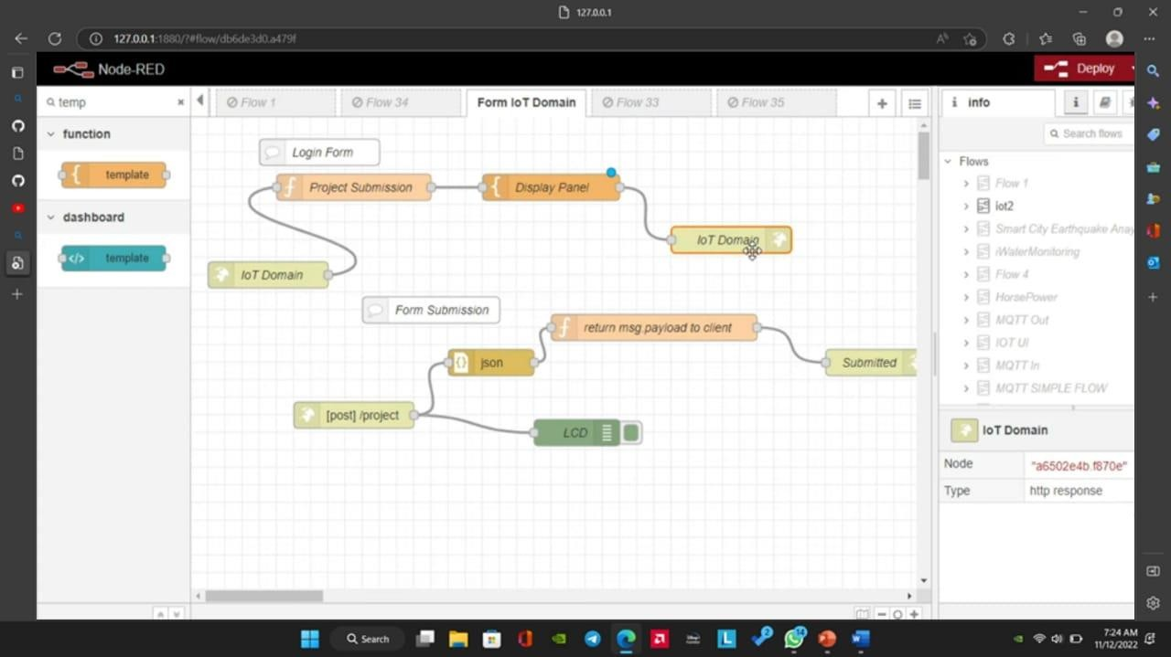

# Designing the structure of the web page

Code used: HTML

**The HyperText Markup Language or HTML** is the standard markup language for documents designed to be displayed in a web browser. It can be assisted by technologies such as Cascading Style Sheets and scripting languages such as JavaScript.

Web template system: Mustache

**Mustache** is a logic-less templating system. A Mustache template is a text string containing text and tags that represent data. The Mustache rendering engine takes a template and substitutes the tags with the data from a given data context.

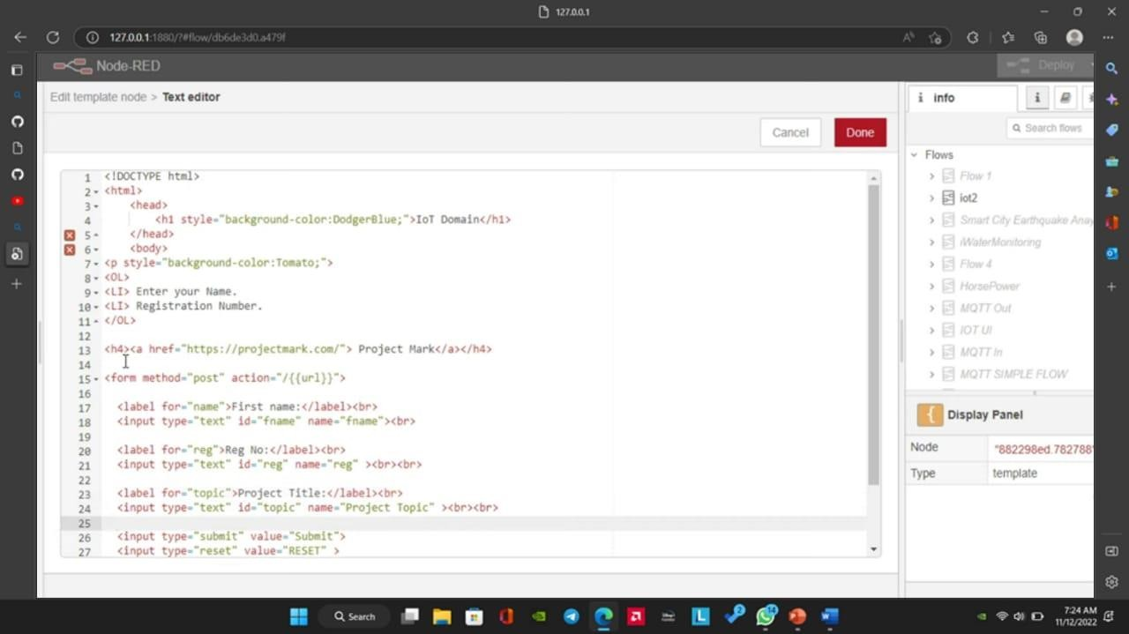

3.Final output

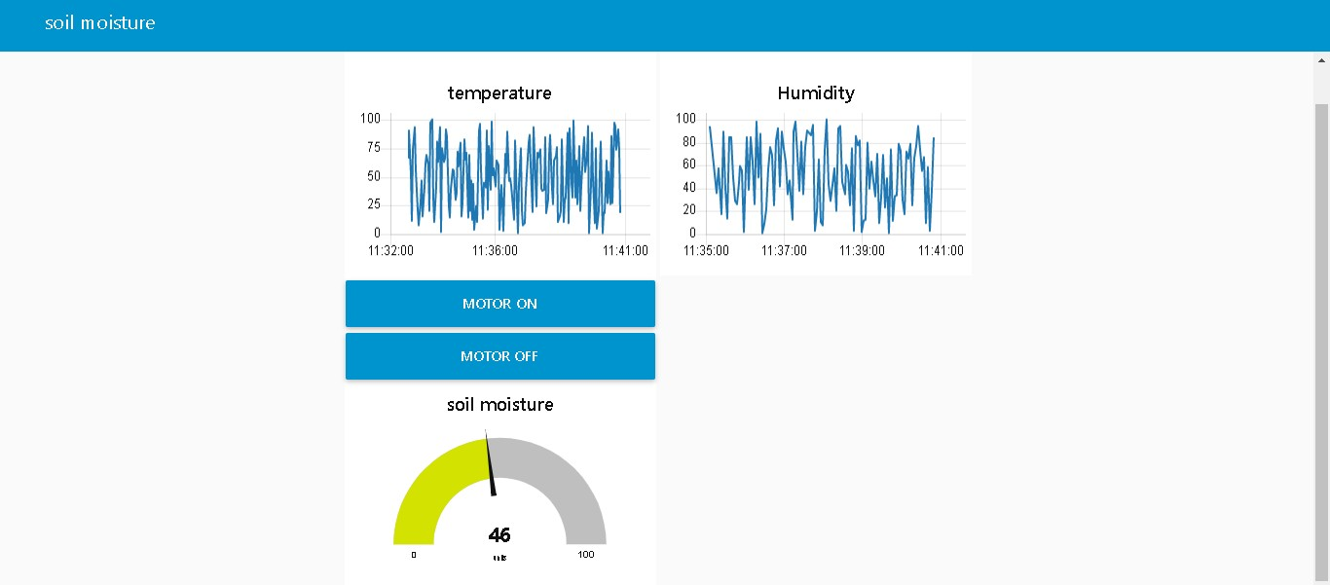

9.RESULTS

The proposed system is developed to detect and monitor the LPG, when a small amount of LPG is brought near the MQ6 sensor it display the message in LCD i.e GAS International Journal of Psychosocial Rehabilitation, Vol.25 issue 02,2021 ISSN: 1475-7192

LEAKAGE” at time of leakage of the gas and the system monitors the LPG level and display the message “HIGH or LOW”. As in recent times, the problem that are faced by the LPG gas customer is gas leakages and booking issues, the developed system will be helpful to the customer.

10. ADVANTAGE & DISADVANTAGE

Advantage

It is used in house as LPG leakage detection

It also detect alcohol so it is used liquor tester

It is possible to get instantaneous results and with high accuracy

Low maintenance and Low operating cost

It does not produce harmful emission like CO,NO and higher hydrocarbon

The sensor has excellent sensitivity combined with a quick fast response time

Disadvantage

Only one gas can be measured with each instrument

It is hazardous as it inflammable gas

It has to be supplied in a heavy steel cylinder

It is costlier than CNG

It is consumed more as it has low energy density

11.CONCLUSION

After this project performance, can conclude that detection of the LPG gas leakage is incredible in the project system. Applicable usefully in the industrial and domestic purpose. In danger situation we are able to save the life by using this system. An alert is indicated by the GSM module. A sensor node senses gas like CO2, oxygen, propane. The estimated range of transmission and consumption of power is obtained. The simple procedures and Arduino UNO Microcontroller are used to build the sensor.

12. FUTURE SCOPE

With recent development in technology, Temperature display during periods wherein no message buffers are empty is one such theoretical improvement that is well possible. Another very interesting and significant improvement would be to accommodate multiple receiver MODEMS at different positions in the geographical area carrying duplicate SIM cards. Multilingual display can be another added variation in the project. Audio output can be introduced to make it user Friendly.

13.APPENDIX

Source code

(1000);

}

}#include< LiquidCrystal >

lcd(5,6,8,9,10,11);

int redled = 2;

int greenled = 3;

int buzzer = 4;

int sensor = A0;

int sensorThresh = 400;

void setup()

{

pinMode(redled, OUTPUT);

pinMode(greenled,OUTPUT);

pinMode(buzzer,OUTPUT);

pinMode(sensor,INPUT);

Serial.begin(9600);

lcd.begin(16,2);

}

void loop()

{

int analogValue = analogRead(sensor);

Serial.print(analogValue);

if(analogValue>sensorThresh)

{

digitalWrite(redled,HIGH);

digitalWrite(greenled,LOW);

tone(buzzer,1000,10000);

lcd.clear();

lcd.setCursor(0,1);

lcd.print("ALERT");

delay(1000);

lcd.clear();

lcd.setCursor(0,1);

lcd.print("EVACUATE");

delay(1000);

}

Else

{

digitalWrite(greenled,HIGH);

digitalWrite(redled,LOW);

noTone(buzzer);

lcd.clear();

lcd.setCursor(0,0);

lcd.print("SAFE");

delay(1000);

lcd.clear();

lcd.setCursor(0,1);

lcd.print("ALL CLEAR");

delay

}

}

|  |  |  |  |
| --- | --- | --- | --- |
|  |  |  |  |
|  |  |  |
|  | | |

GitHub: <https://github.com/IBM-EPBL/IBM-Project-44831-1660726980>

Project Demo Link: <https://www.mediafire.com/file/2tv1w98zzvtg47d/Video_2022_11_16-2+(1).webm/file>

|  |  |  |  |  |
| --- | --- | --- | --- | --- |
| |  | | --- | |  | |  |  |  |

|  |  |  |  |  |
| --- | --- | --- | --- | --- |
| |  | | --- | |  | |  |  |  |